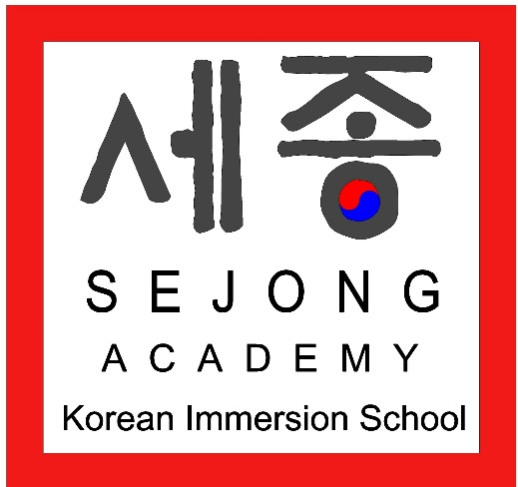

Sejong Parent Involvement Plan
Revised August 2018
Board Approved: Pending – Sept. Meeting
SEJONG ACADEMY’S VISION
Sejong Academy students will become scholars of Korean and English, as well as socially responsible global citizens.
SEJONG ACADEMY’S MISSION
Sejong Academy is committed to providing an academically rigorous education to K-8 Twin Cities students through immersion experience in Korean language and culture by using research-based curriculum, high standards for accountability and promoting an appreciation for diversity and international cultures.
Sejong Academy started in the Fall of 2014 with a K-6 program and 62 students. As of the Fall of 2018, we have 196 students, PreK-8. We believe that through the study of Korean language and culture as implemented at our school, students will learn to be socially responsible, globally competent scholars in English and Korean. A few key beliefs we have are:
- All students will be held to academically rigorous standards
- All students benefit from learning languages and cultures
- The world’s best work force will be a globally competent workforce where workers thrive and seek out diversity
- All staff need to be trained on how to involve families, parents and the community.
- Language immersion can benefit all students from all language backgrounds and socio-economic statuses
- All parents and students need to know exactly how they are doing academically on objective and subjective measures, as well as how they are doing socially and emotionally
Sejong Academy has a strong network of parents, volunteers and extended family members who support their children and their learning. Education and family are two foundational components of Korean culture, and we work to instill those strong values here as well. We have several opportunities to get parents involved and will continue to think creatively about ways to build a community school that will be a gathering place for families, students and friends. We work to involve parents in all aspects of program planning and implementation. The following documents will detail the initiatives in place, as well as put forth a vision for parental involvement going forward.
Title One Parent and Family Involvement
Sejong Academy has been approved for Title One funding based on direct certification which is also used for food service. We have operated our Title One program as a targeted services approach which targets those students who are eligible and need extra assistance. We have used this funding to provide supplemental homework help, reading and math instruction and enrichment in our after school program. We provide translation services for all parent involvement events.
Open Houses and Regular Parent and Family Involvement Events
Objectives:
- Build relationships with families and staff
- Introduce the school and our programs to parents and prospective parents
- Optional event but the event will be communicated to all families in their primary language and transportation will be offered
- PTO will support and be represented at all open houses to foster parent to parent communication, build community and increase parent involvement.
Event | Date (s)/Frequency | Parents and Staff Involved
Back to School Open House | August 16, 2018, 4-6 PM  Held the Thursday before school starts each academic year | All staff and parents are involved. Parent participation is encouraged but not required.
Mid-Year Open House for Current and Prospective Families | December 12, 2018, 3:00-5:00 PM. | Current staff, parents and prospective parents welcome but not required
Summer Open House | Summers | Current Staff
Parent-Teacher Conferences | Twice a year in the Fall and Winter | All staff, teachers and parents. Transportation provided to those who need it.

Korean Cultural Events
Objectives:
- Build community between staff, parents and the community
- Learn about Korean culture to support Korean language learning
- There will be a sit down meal at a minimum of two of these events
Event | Date (s) | Parents and Staff Involved
Sejong Academy Chusoek Celebration, (Korean Harvest Festival) | Late September, 5-6:30 PM, Sejong Academy | All staff and all parents and family members are welcome
Lunar New Year Festival | February each year, 5-7 PM | All staff and all parents and family members are welcome
Student Talent Show and Carnival | Spring each year | All staff, students, parents and interested community members. Any cultures can be represented at this event.

Family, Parent and Community Information Events
Objectives:
- Inform parents about Sejong Academy’s major curriculum components
- Build community with parents and ask for basic homework support
- Talk to EL parents in their native language about major EL support and our EL Plan of Service
Event | Date (s) | Parents and Staff Involved
Curriculum Night/Family Reading Night | October each year | Director, Teachers, Parents and Staff
Title One and EL Parent Information Nights | Three times a year | EL Teacher, Director, Teachers, Parents and Staff. Community liason will provide translation and Sejong Academy will offer transportation to families.
Title One Parent Involvement Committee and School Leadership Team | Formed during the 2017-2018 Academic Year | Parents, staff, teachers and community members

Parent Teacher Organization
Objectives:
- Build community with the parents, teachers, staff and greater school community
- Provide assistance with fundraising, recruiting and school wide events
Event | Date (s) | Parents and Staff Involved
Monthly Meetings | Second Thursdays at 5 PM | Parents, teachers, and staff
School Carnival | June each year | PTO, Director, teachers, staff and surrounding community.
Fundraising events | Varies | Parents and staff
Support Korean Cultural Events | Throughout the year including Korean thanksgiving and Lunar New Year | Parents, teachers, staff and community members

Parent Communication
Objectives:
- Maintain frequent and timely communication with parents
- All parent communication is translated for parents whose native language is not English or who request translation
- Parents are continuously and honestly informed of their children’s academic work
Form of Communication | Date (s)/Frequency | Parents and Staff Involved
Newsletters | Monthly | Staff compile and send to parents
NWEA Score Reports | Following Fall, Winter and Spring sessions | Staff compile and send to parents
Report Cards | Quarterly | Staff compile and send to parents
MCA results | MCA-Spring` | Staff compile and send to parents
Schoology | Weekly | Teachers post assignments and grades and parents can view
Important Updates | Throughout the year | Staff compile and send to parents
Parental Needs Assessment/Survey | Twice a year | Staff compile and send to parents

